NAME : B Tharun kumar reddy

REG NO :192111508

Course : software engineering

Code : CSA1001

Faculty name :DR G Mary valantina

Date :26/09/2022

EXPERIMENT:1

ONLINE VOTING SYSTEM

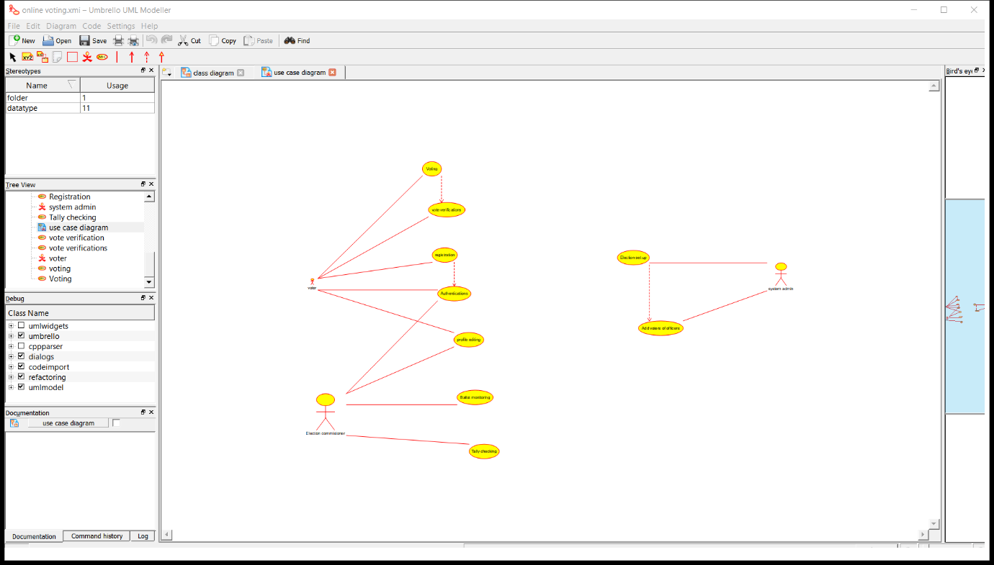

RESULT: I had done this program successfully in umbrello sostware

EXPERIMENT :2

LIBRARY MANAGEMENT SYSTEM

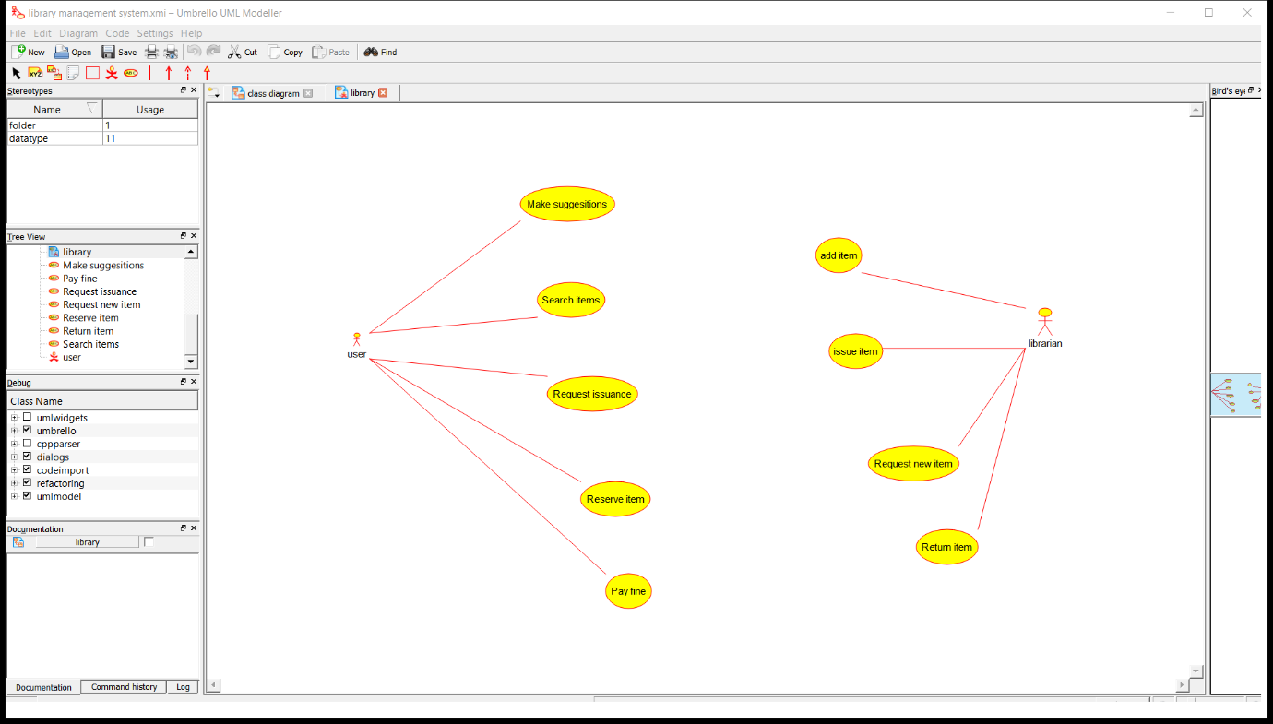

RESULT: I had done this program successfully in umbrello sostware

EXPERIMENT :4

ONLINE SHOPPING SYSTEM

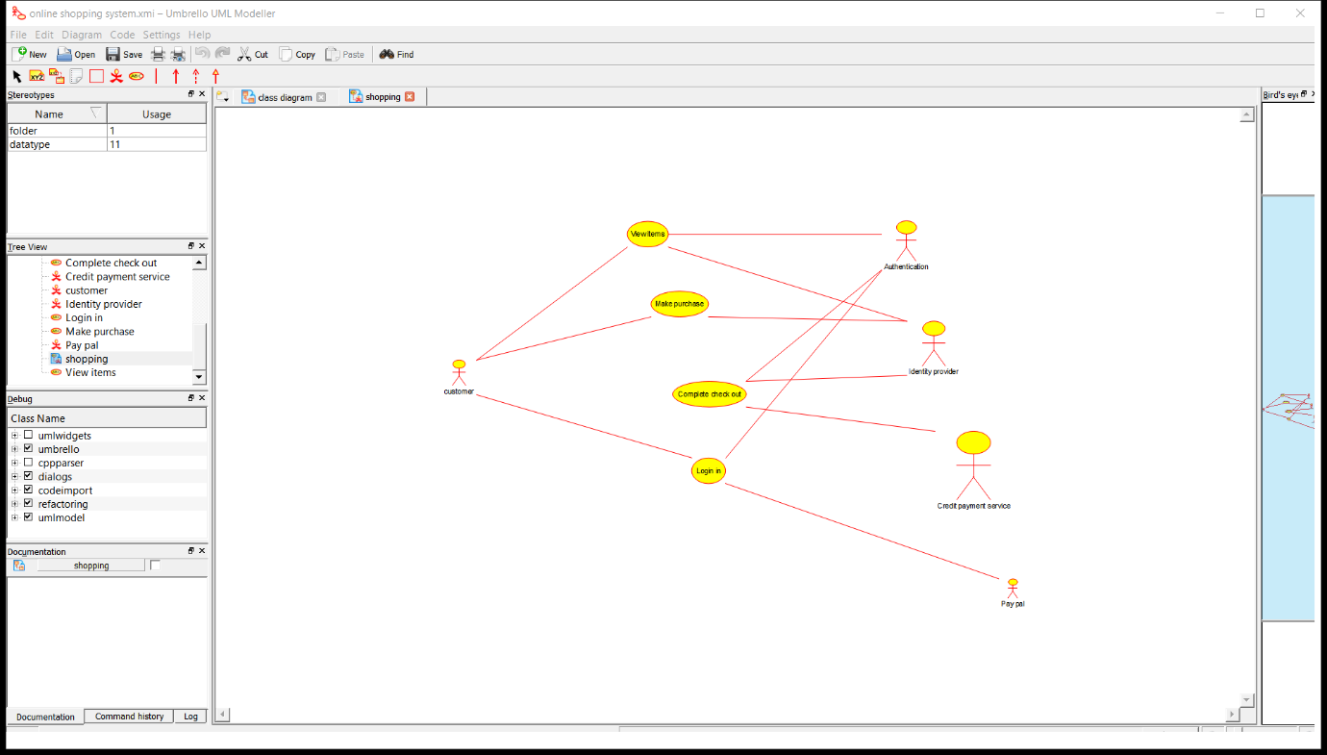

RESULT: I had done this program successfully in umbrello sostware

EXPERIMENT:5

ONLINE RAILWAY RESERVATION SYSTEM

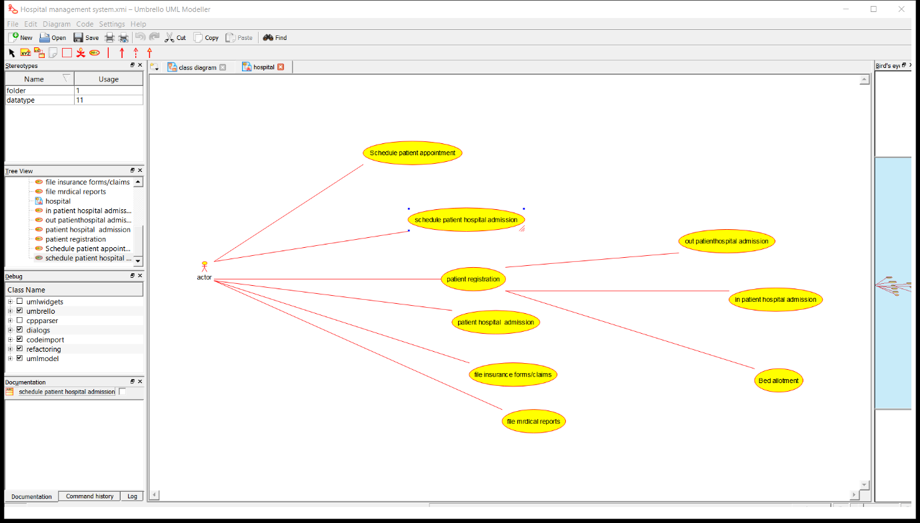

RESULT: I had done this program successfully in umbrello sostware

s